RH Series
User guide
Statement: The specifications and statements of this user manual are for reference only.The company has the right to change the product or specifications at any time without notice.
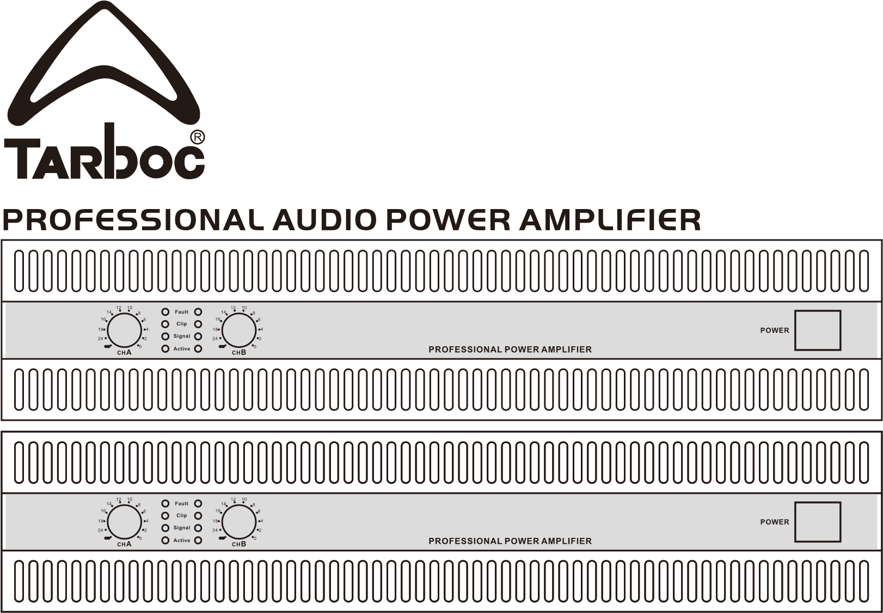

Front panel and rear panel functions:
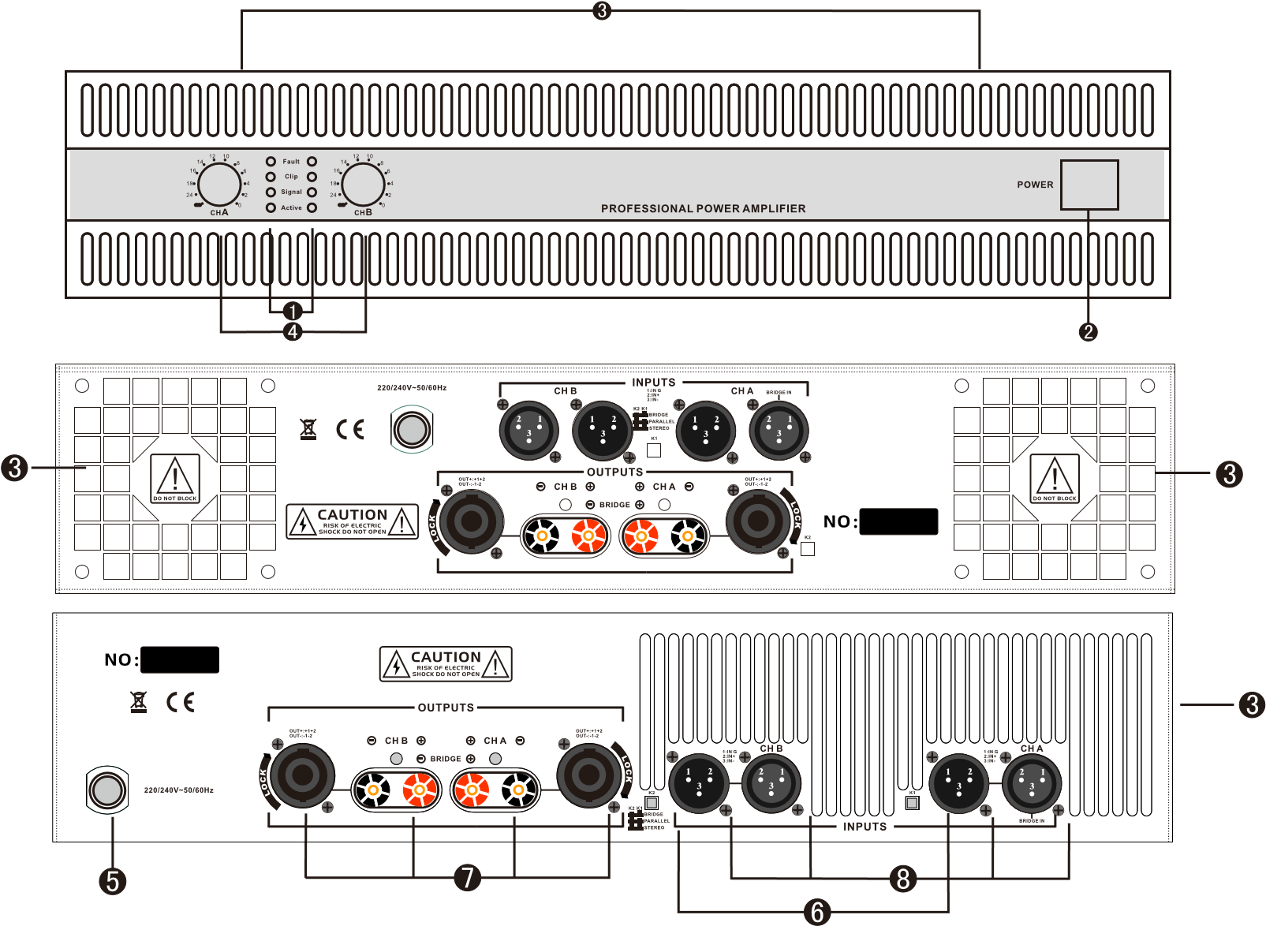
Front panel west lane function display lights: protection/failure indicator light (Fault), limit indicator light (Clip), signal indicator light (Signal), operation indicator light (Active). power switch ventilation hole A,B volume control 5 power line
6
Working mode selection switch 7 Speakon output connection socket 8 input socket
Installation of working mode:
The product has three functions:stereo,bridging,well connection,and three functions,which can be passed through K1 and K2 on the rear panel. The combination of key switches to choose.
1.Stereo working mode
Turn off the power amplifier before connectingand throwK1and K2to the STEREO position according to the figure belowPlease pay attention to the positive and negative pieces of the speaker when wiring.Be careful!
The signal is input from the A channel input socket, and the A channel SPEAKON and the terminal are output.
The signal is output by B channel input socket,
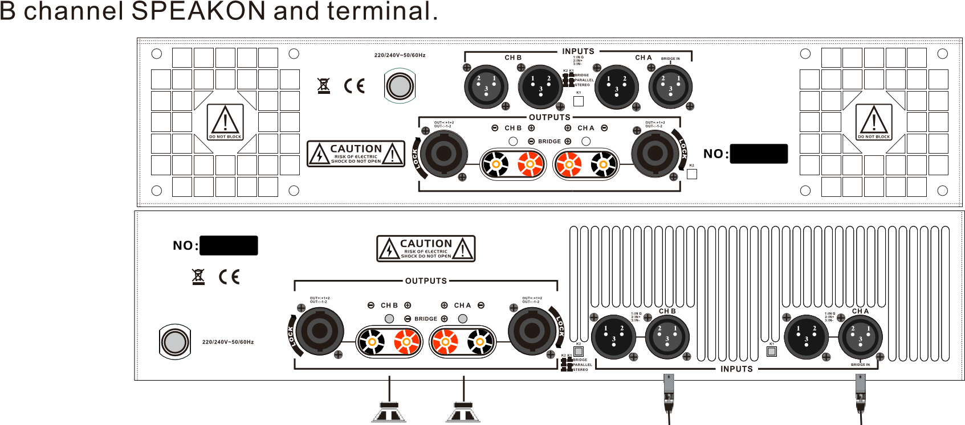
04
Notes:
Warning!
Installation:
This device can only be plugged into the AC power outlet indicated in this user manual or the specifications shown on this adapter.Otherwise, it may cause fire or electric shock.
Do not let the water enter the person's clothes straight or get damp.One hundred may cause afire or electric shock.
Do not put containers containing liquids or small metal objects on this device.Otherwise liquid or small metal items falling into the device may cause fire or electric shock.
Do not press heavy objects(including this device)on the power cord.Otherwise,the power cord may be damaged, which may lead to fire or electric shock.Pay special attention not to press heavy objects on the power line covered by the carpet.
Operation:
Do not scratch,dome,twist,stretch or heat the power cord. Incense may pre-injure the power cord,which will lead to Fire or electric shock.
Don't use it to charge it directlyIncense may cause electric shock.If you think that the interior needs to be repaired, maintained or repairedplease contact the agent key dealer. Please do not modify this device. Incense may cause fire or electric shock.
lf there is an internal lightning strike, please turn off the power switch as soon as possible, and plug in the power cable from the power supply.
If lightning may occurdo not touch the plug of the power cable when plugged in.Hundreds of cases may cause electric shock.
When an exception occurs during operation:
If the power cord is pre-depre-cored(such as cut off or state line nakedmoney), please get the replacement from the agent dealer.Use the injured electricity. Continued use of this device by the source wire may cause fire or electric shock.
lf the device falls from a height or the shell is damaged, please turn off the ontact the
agent Do not continue topowerimmediately,pull out the power plug from the AC power outlet, and c use this killing precaution,which may cause a fire or electric shock.
When any abnormality is found,such as smoke,odornoise or foreign matter or liquid entering the device, please turn off the power switch immediately.The well pulls the power cord plug out of the AC power outlet.Please ask the agent dealer to repair it on your behalf.If you continue to use it at this time,it may lead to fire or electric shock.
Attention!
Installation:
Please avoid using this device in the following situations:
— Second,be exposed to splashed oil foam and steam, such as near kitchen stoves,humidifiers and other places.
— An unstable surfacesuch as a shaking surface or a surface.
— Exposure to an overheated environment,such as in a closed car or a place exposed to direct sunlight.
— Exposed to high humidity or where dust accumulates.
Do not place the power cable near the heater.Otherwise, it may lead to melting and cause a fire.
01
Please grasp the plug part when unplugging the power plugfrom the AC power outlet. Do not pull the cable straight. Otherwise,the power cord may be damagedwhich may lead to fire or electric shock.
Do not touch the power plug with wet hands.Otherwise, it may lead to electric shock.
There are ventilation holes on the front and back of this package to avoid the internal temperature rising too high. Do not block these vents.Blocking the vents may cause a fire.Pay special attention ,do not.
First, put the device sideways or upside down.
Put this device in a poorly ventilated place,such as abookcase or closet,instead of installing it on the attached special bracketUp.
Cover the device with a tablecloth,or put it on the carpet and bed.
Please keep enough space around this device to facilitate normal ventilation.
The reserved space should be at least 10cm on both sides and at least 10cm above. if sufficient air flow is not maintainedthe internal temperature of the device will rise and may lead to a fire.
To move the position of this device,please first unplug the power plug from the AC power outlet and pull out all the connecting cables.Otherwise, the cable may be
damaged,which may lead to fire or electric shock.
Operation:
When the speaker is connected to the amplifier output socketonly a dedicated cable for the speaker can be used.The use of other cables may cause fire.
When connecting this device,please turn off all instruments,audio equipment and speakers firstPlease use the correct cable.Connect according to the regulations.
Before turning on the power of this device,be sure to turn the volume control to the minimum. Otherwise, the sudden explosion of sound may damage your hearing.
If you are tired and it is inconvenient to use this device for a long time,if you are going to have a long vacation,please take the power plug out of the AC power outlet. Incense may cause the fire to go out.
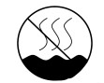


Please put the amplifier accessories(such as feet,instruction manual pockets,etc.) in places that are not easy for children to get.
This symbol means "Only applicable to safe use at an altitude of 2,000 meters and below.
The symbol means "only applicable to non-tropical climate conditions.

introduce briefly
Thank you very much for choosing our company's professional audio power amplifier.
For your safety,enlarge Yili in installation and operation. Please read the previous notes first.
Our company specializes in first-frequency power amplifiers.it has stable lines,reasonable heat dissipation layout and carefully selected elements. The device,lean manufacturing process, andlong-term aging test ensure that the power amplifier has excellent performance and reliability Functional features:
High-efficiency heat dissipation camp,roughly under the speed of the cooling fan, to ensure that the amplifier works at my low temperature.
Large ring transformer to ensure sufficient power supply.
Exquisite shape, cup-level installation hole.
STERERO,BRIDGE,PARALLEL
Because it is equipped with two input sockets and two output sockets(Speakon and terminal),our products can be used for a wide range of purposes and various installation system requirements.
Each channel has its own purpose Signal and Clip.
When the protection circuit works,Fauul means that the light is not finished, and the sound output will stop automatically.
Front panel level gain control.
Perfect protection,including limit,on/offimpact protectionDC protecionoutput short circuit protection,overheating protection.
RH Product technical parameters
 | Model |  |  | RH500 | RH600 | RH900 | RH1100 | RH1300 | RH1500T
 | Rated power (8 Ω) | 2*200W | 2*300W | 2*500W | 2*600W | 2*900W | 2*1100W | 2*1300W | 2*1500W
 | Rated power (4Ω) | 2*300W | 2*450W | 2*750W | 2*900W | 2*1350W | 2*1650W | 2*1950W | 2*2250W
 | Rated power ( Bridge 8Ω) | 600W | 900W | 1500W | 1800W | 2700W | 3300W | 3900W | 4500W
 | Frequent response | 20Hz-20kHz:+0.1/0.3dB(1W/8Ω)
 | Total harmonic distortion | <0.05% | <0.05% | <0.05% | <0.05% | <0.05% | <0.05% | <0.05% | <0.05%
 | Damping  coefficient | >300:1 | >300:1 | >300:1 | >350:1 | >350:1 | >350:1 | >350:1 | >350:1
 | signal-to-noise ratia | >103dB | >103dB | >103dB | >103dB | >103dB | >103dB | >103dB | >103dB
 | Voltage corversion slaughter | 40Xstandrd | 40Xstandrd | 40Xstandrd | 50Xstandrd | 50Xstandrd | 50Xstandrd | 50Xstandrd | 50Xstandrd
 | Input gain | 0.775V
 | Input  impedance | Balanced20Kohm/non balanced10Kohm
 | Power supply voltage | AC~220-240V/50-60Hz
 | External dimensions | 2U(483mm*280mm*88mm) |  |  | 2U(483mm*350mm*88mm)

2.Bridge working mode
Please note that the connection of the bridge working mode is very different from the stereo working mode.
Turn off the power amplifier before connecting,and adjust the AandBchanne volume controlpotentiometer knobs to the minimum "counterclockwise to the end), andPress KI and K2 straight to BRIDGE, which is not wired as shown in the figure below. The signal must be input separately from the A channel, the well is adjusted by the A knob, and the output is composed of the positive poles of A and the positive poles of B.
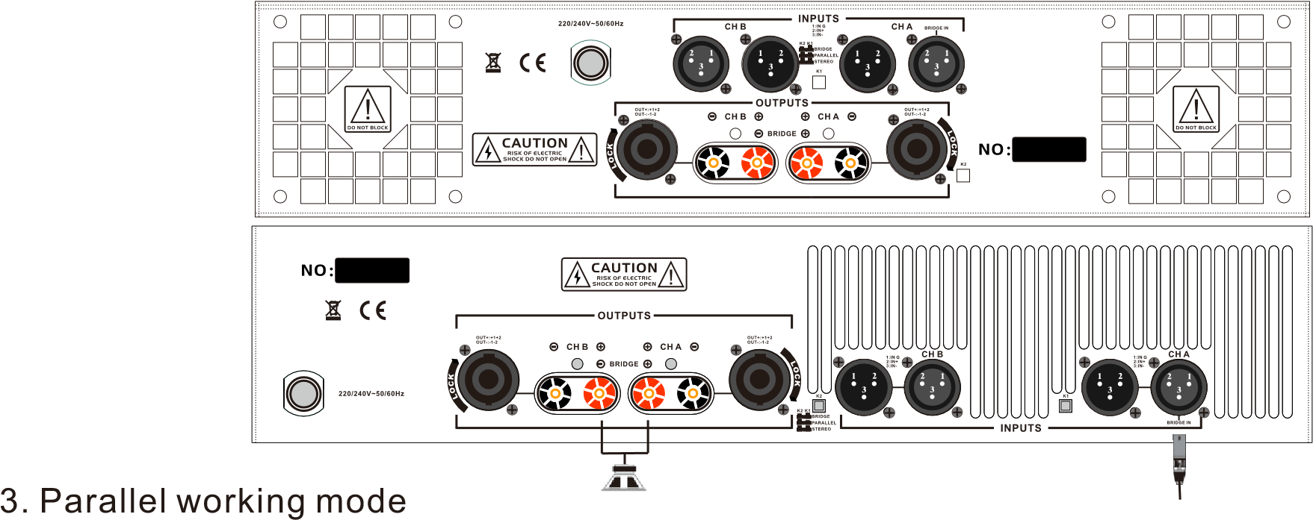
Well connection mode can send the same signal to two channels without using extemal wiring.
Turn off the power amplifier before connecting,and adjust the Aand B channel volume control potentiometer knobs to the minimum (adjust counterclockwise to the end), andKl and K2 are thrown straight to the PARALLEL position,which is not wired as shown in the figure below.
The signal is input separately by channe! A,A and B are output respectively,and the panel A knob and B knob control their volume respectively.
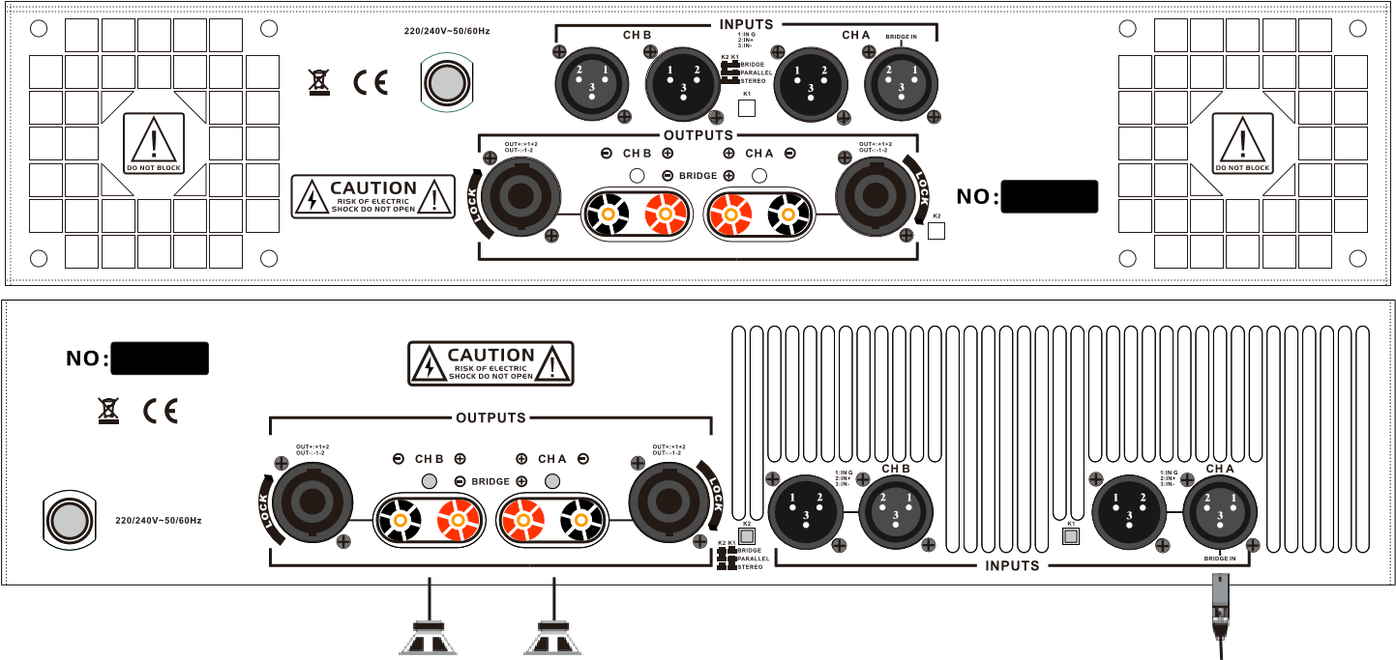
Operation steps:
1.select the working mode for input and output connection(please refer to the installation section).
2. The volume potentiometer must be set to the minimum before connecting the AC power supply.
( Adjust it counterclockwise to the end)
3.After the power supply of the power amplifier,the running light area on the panel is always on.
4. When adjusting the volume potentiometer, the green signal light of the panel should shine with the adjustment size.
5.The red indicator light(Clip LED) on both sides is the limit indicator of the two channels.If the limit indicator lightflashes, it means that the output signal has been limited.When the amplifier
is working normally,it is normal for the limit indicator light to shine intermittently.
6. If the limit indicator light shines continuously for too long,the volume control potentiometer should be appropriately reduced.
05

